Algorithms

Algorithm
An algorithm is a finite step-by-step list of well-defined instructions for solving a particular problem.
Types of Algorithms
Algorithm types we will consider
• Divide and conquer
• Dynamic programming
• Greedy Method
• Backtracking
• Branch and Bound
• Serial or parallel or distributed algorithm
• Deterministic or non-deterministic algorithm
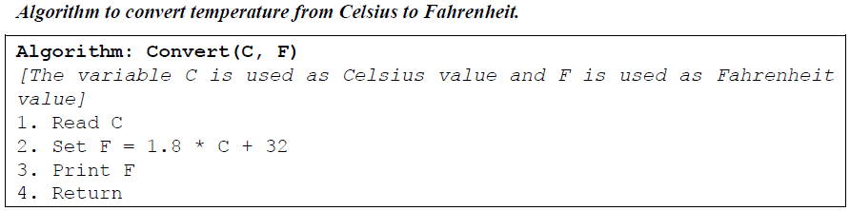
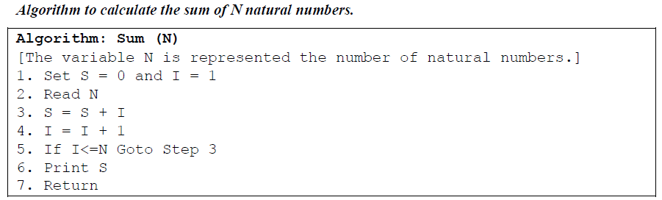

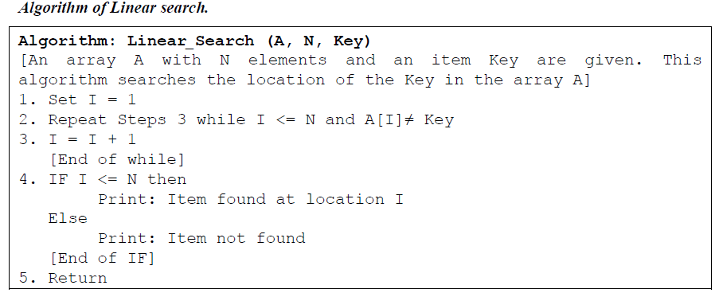
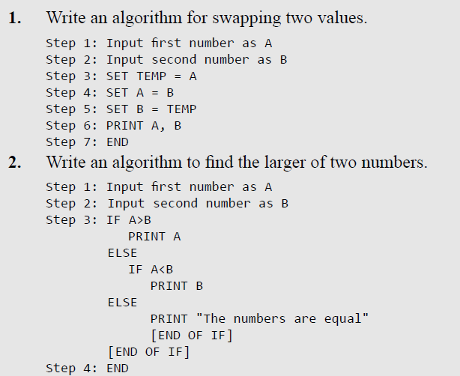
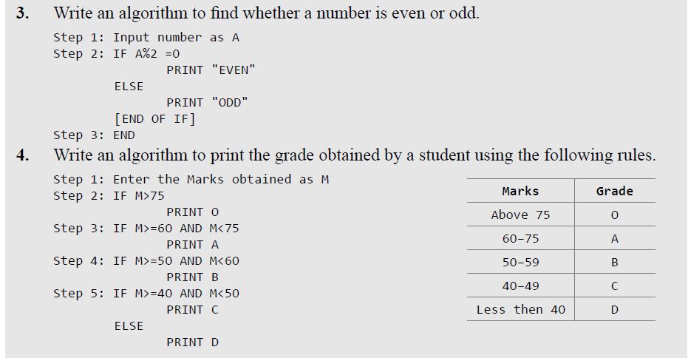
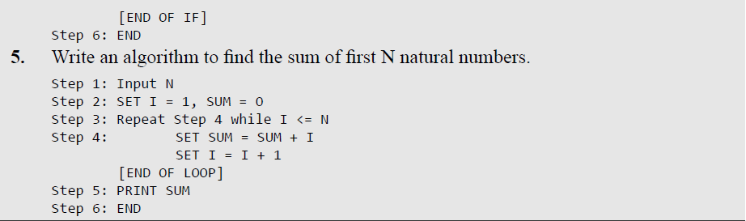

Space Complexity
- The space complexity of an algorithm is the amount of space (computer memory) that is required during the program execution as a function of the input size

- Generally, the space needed by a program depends on the following two parts:
- Fixed part: It varies from problem to problem. It includes the space needed for storing instructions, constants, variables, and structured variables (like arrays and structures).
- Variable part: It varies from program to program. It includes the space needed for recursion stack, and for structured variables that are allocated space dynamically during the runtime of a program.
- Therefore, space complexity of a program P is S (P) = C + Sp (I)
- Where C is the fixed space requirement independent of a particular problem and Sp (I) is the variable Space requirement depends on the instance characteristics I.
- Space complexity can express that result in big O notation.

- Example:
- Consider the following algorithm.

Algorithm: INT SUM (A, N)
IF N ≠ 0 then return SUM (A, N-1) + A [N-1]
Return 0
- The above recursive function for summing a list of numbers.
- memory space is required for each recursion call of the function
- 2 bytes of the parameter A, 2 bytes for the parameter N and 2 bytes for the return value.
- The total space required per recursive call 6 bytes and N number of recursive calls are required to summing the list.
- Therefore, we get SSUM (I) = SSUM (n) = 6n.
- Can also be written as O(n) = 6n

Time Complexity
- The time complexity of an algorithm is basically the running time of a program as a function of the input size.
- In other words, the number of machine instructions which a program executes is called its time complexity.

Worst-case running time
- This denotes the behavior of an algorithm with respect to the worst possible case of the input instance.
- The worst-case running time of an algorithm is an upper bound on the running time for any input.
- Therefore, having the knowledge of worst-case running time gives us an assurance that the algorithm will never go beyond this time limit.
- For example, the worst case for a simple linear search on a list occurs when the desired element is found at the last position of the list or not on the list.

Average-case running time
- The average-case time complexity of an algorithm is a measure of average time of all instances taken by an algorithm.
- It specifies the expected behavior of the algorithm when the input is randomly drawn from a given distribution.
- Average-case running time assumes that all inputs of a given size are equally likely.

Best-case running time
- The best-case time complexity of an algorithm is a measure of the minimum time that the algorithm will require.
- For example, the best case for a simple linear search on a list occurs when the desired element is the first element of the list.
- However, while developing and choosing an algorithm to solve a problem, we hardly base our decision on the best-case performance.
- It is always recommended to improve the average performance and the worst-case performance of an algorithm.

Time–Space Trade-off
- The best algorithm to solve a particular problem at hand is no doubt the one that requires less memory space and takes less time to complete its execution.
- But practically, designing such an ideal algorithm is not a trivial task.
- There can be more than one algorithm to solve a particular problem.
- One may require less memory space, while the other may require less CPU time to execute.
- Thus, it is not uncommon to sacrifice one thing for the other.
- Hence, there exists a time–space trade-off among algorithms.
- So, if space is a big constraint, then one might choose a program that takes less space at the cost of more CPU time.
- On the contrary, if time is a major constraint, then one might choose a program that takes minimum time to execute at the cost of more space.

Expressing Time and Space Complexity
- The time and space complexity can be expressed using a function f(n) where n is the input size for a given instance of the problem being solved.
- The number of machine instructions which a program executes is called its time complexity.
- This number is primarily dependent on the size of the program’s input and the algorithm used.
- Expressing the complexity is required when we want to predict the rate of growth of complexity as the input size of the problem increases.
- There are multiple algorithms that find a solution to a given problem and we need to find the algorithm that is most efficient.
- The most widely used notation to express this function f(n) is the Big O/ notation. It provides the upper bound for the complexity.

Algorithm Efficiency
- While measuring the time complexity (efficiency) of an algorithm, we concentrate on the frequency count of all key statements (important statement).
- The number of statements executed in the program for n elements of the data is a function of the number of elements, expressed as f(n).
- If a function is linear (without any loops or recursions), the efficiency of that algorithm or the running time of that algorithm can be given as the number of instructions it contains.
- However, if an algorithm contains loops, then the efficiency of that algorithm may vary depending on the number of loops and the running time of each loop in the algorithm.

Constant Time

Doesn’t contain loop, recursion and call to any other non-constant time function.

Example
a = a + 1
In this algorithm, the frequency count of key statement a = a + 1, is one. There is no “n” involved so we don’t write f(n).

Linear Loops

- To calculate the efficiency of an algorithm that has a single loop, we need to first determine the number of times the statements in the loop will be executed.
- This is because the number of iterations is directly proportional to the loop factor.
- Greater the loop factor, more is the number of iterations.

Example
- For example, consider the loop given below:

for(i=0;i<100;i++)
statement block;

- Here, 100 is the loop factor. We have already said that efficiency is directly proportional to the number of iterations.

- Hence, the general formula in the case of linear loops may be given as

f(n) = n

Example:

Algorithm
For I = 1 to n
a = a + 1
[End of loop]
In this algorithm, the frequency count of key statement a = a + 1, is n.

- Consider the loop given below:

for(i=0;i<100;i+=2)
statement block;

- Here, the number of iterations is half the number of the loop factor.
- So, here the efficiency can be given as
f(n) = n/2

Consider following function:

bool arrayContainsElement(int arr[], int size, int element)
{
for (int i = 0; i < size; i++)
{
if (arr[i] == element)
return true;
}
return false;
}

Here we might have 100 items in our array, but the first item might be that element, in this case we would return in just 1 iteration of our loop.

In general we'd say this is O(n) runtime and the "worst case" part would be implied. But to be more specific we could say this is worst case O(n) and best case O(1) runtime. For some algorithms we can also make rigorous statements about the "average case" runtime.

Logarithmic Loops
- In logarithmic loops, the loop-controlling variable is either multiplied or divided during each iteration of the loop.
- For example, look at the loops given below:

for(i=1; i<1000; i*=2)
statement block;

for(i=1000; i>=1; i/=2)
statement block;

- Consider the first for loop in which the loop-controlling variable i is multiplied by 2.
- The loop will be executed only 10 times and not 1000 times because in each iteration the value of I doubles.
- Now, consider the second loop in which the loop-controlling variable i is divided by 2.
- In this case also, the loop will be executed 10 times.
- Thus, the number of iterations is a function of the number by which the loop-controlling variable is divided or multiplied.
- In the examples discussed, it is 2.
- That is, when n = 1000, the number of iterations can be given by log 1000 which is approximately equal to 10.

How:
a^{y} = x
log_{a}(x) = y

10¹⁰ = 1000
- Here a =2, the number dividing the loop variable.
log₂(1000) = 10 by this formula: (log₁₀(1000)/log₁₀2)
- We can also see the above formula by dividing/multiplying by 3.
- Therefore, putting this analysis in general terms, we can conclude that the efficiency of loops in which iterations divide or multiply the loop-controlling variables can be given as f(n) = log n

Nested Loops
- Loops that contain loops are known as nested loops.
- In order to analyse nested loops, we need to determine the number of iterations each loop completes.
- The total is then obtained as the product of the number of iterations in the inner loop and the number of iterations in the outer loop.
- In this case, we analyze the efficiency of the algorithm based on whether it is a linear logarithmic, quadratic, or dependent quadratic nested loop.

Linear logarithmic loop
- Consider the following code in which the loop-controlling variable of the inner loop is multiplied after each iteration.
- The number of iterations in the inner loop is log 10.
- This inner loop is controlled by an outer loop which iterates 10 times.
- Therefore, according to the formula, the number of iterations for this code can be given as 10 log₂ 10.

for(i=0;i<10;i++)
for(j=1; j<10;j*=2)
statement block;
- In more general terms, the efficiency of such loops can be given as f(n) = n log n.

Quadratic Loop:

- In a quadratic loop, the number of iterations in the inner loop is equal to the number of iterations in the outer loop.
- Consider the following code in which the outer loop executes 10 times and for each iteration of the outer loop, the inner loop also executes 10 times.
- Therefore, the efficiency here is 100.

for(i=0;i<10;i++)
for(j=0; j<10;j++)
statement block;

The generalized formula for quadratic loop can be given as f(n) = n²

Dependent quadratic loop
In a dependent quadratic loop, the number of iterations in the inner loop is dependent on the outer loop.
- Consider the code given below:
for(i=0;i<10;i++)
for(j=0; j<=i;j++)
statement block;
- If the external loop is running for 10 times, the statement block executes for a total of 55 times, which actually the sum of numbers from 1 to 10.
- So we can generalize is as if the external loop is run n times, the sum of numbers from 1 to n is given by formula n(n+1)/2.
- Therefore, the efficiency of such a code can be given as

f(n) = n (n + 1)/2

Asymptotic Efficiency:
asymptotic efficiency of algorithms is study of order of growth of the running time

Big-O (“big oh”) Notation (Upper Bound)
O-notation characterizes an upper bound on the asymptotic behavior of a function.

In other words, it says that a function grows no faster than a certain rate, based on the highest-order term.

- This factor is the Big O, and is expressed as O(n).
- The Big O notation, where O stands for ‘order of’ is concerned with what happens for very large values of n.
- It is a measure of the longest amount of time it could possibly take for the algorithm to complete.
- The big-O notation is the formal method of expressing the upper bound of an algorithm's running time.
- 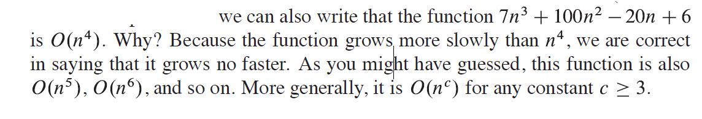
- Using big-O notation, we do not have to worry about the hardware and software used to implement an algorithm.
- . Big-O notation is used extensively to estimate the number of operations an algorithm uses as its input grows.
- With the help of this notation, we can determine whether it is practical to use a particular algorithm to solve a problem as the size of the input increases.
- Furthermore, using big-O notation, we can compare two algorithms to determine which is more efficient as the size of the input grows.
- The functions to which we apply asymptotic notation will usually characterize the running times of algorithms.

Big O Notation Rules:
A number of rules to manipulate asymptotic notations are followed:
Rule 1: O ( c f (n)) = O (f (n))
Rule 2: O (O (f (n)) = O (f (n))
Rule 3: O (f (n) g (n)) = f (n) O (g (n))
Rule 4: O (f (n) O (g (n)) = O (f (n) g (n))
Rule 5: O (f (n) + g (n)) = O (max (f (n), g (n))
Rule 6: If f(n) = O(g(n)) and g(n) = O(h(n)), then f(n) = O(h(n)). [Transitivity Rule]

Certain terms dominate others:
We ignore/drop the low-order terms.
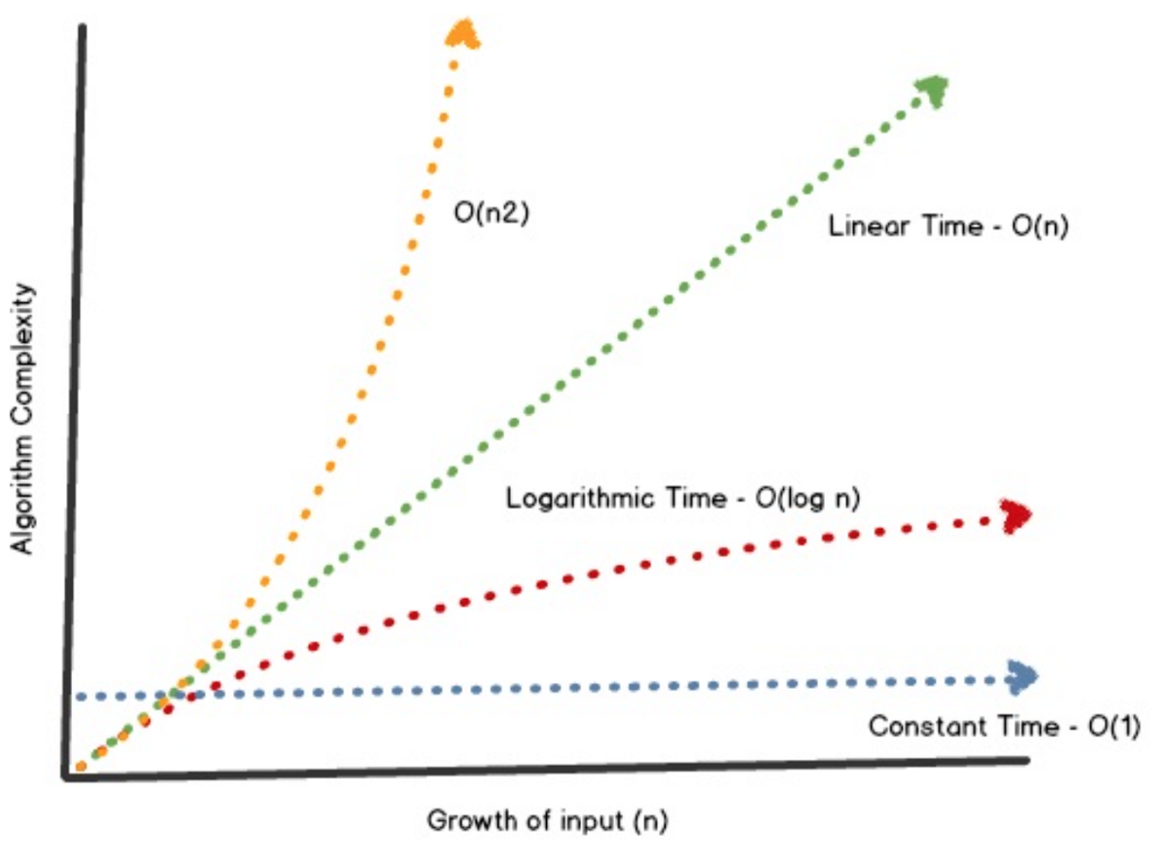

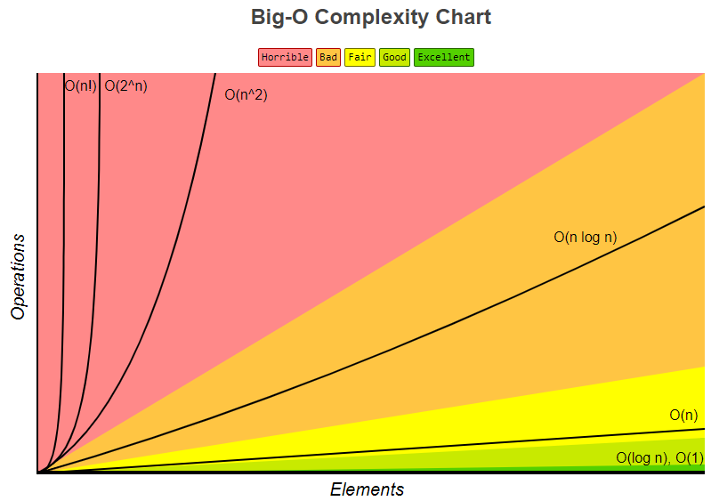
(source: bigocheatsheet.com)

Examples Constant Time:
Time complexity of a function (or set of statements) is considered as O(1)
Example 1:
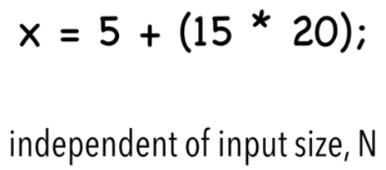
Complexity:
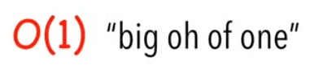

Example 2:
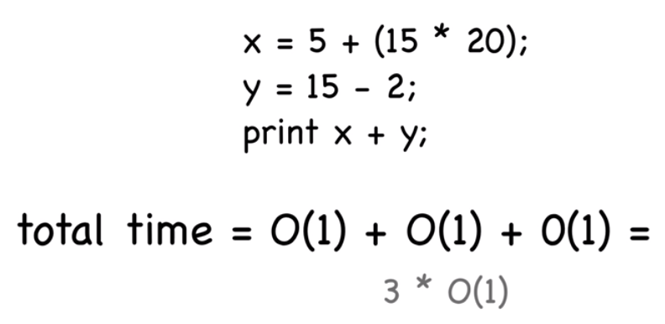
However, since we drop constants, so complexity of above statements is still O(1)

@@@@@@@@@@@@@@@@@

Examples Linear Time

Example 1:
f(n) = 5n,
Ignore constants (Rule 1)

Then, O(5n) = O(n)
Reason: If ‘n’ goes large, 5 does not matter.

Example 2:
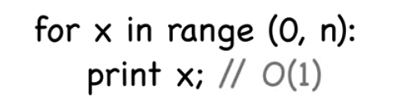
The complexity of above statements is = O(n)

Example:
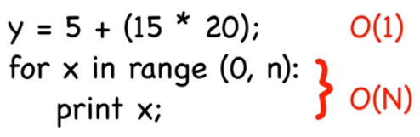
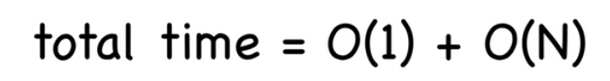
However, since we drop the complexity of low order terms, the complexity will be O(N)

Example:
- Suppose, an algorithm consists of two independent parts-A1 and A2.
- These parts may be considered as a sub-algorithm or a single instruction.
- Let us assume that A1 and A2 take time t1 and t2 respectively for computation.
- Now, whenever these two parts are in a sequential structure that means first A1 is computed, and then A2 is computed, denoted by A1: A2, the total computation time is t1 + t2.
- According to maximum rule, Rule 5, the computation time denoted by max (t1, t2).

Example:
Suppose t₁ = O (n²) and t₂ = O (n), calculate the total computation time for A1:A2
Answer:
Using Rule 5
For A1:A2, computation time = t1 + t2
= max (t1, t2)
= max (O (n²), O (n))
= O (n²)

@@@@@@@@@@@@@@@@@

Examples: Quadratic Time
Example 1:
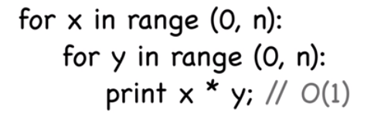
The time complexity should be O (n²)

Example:
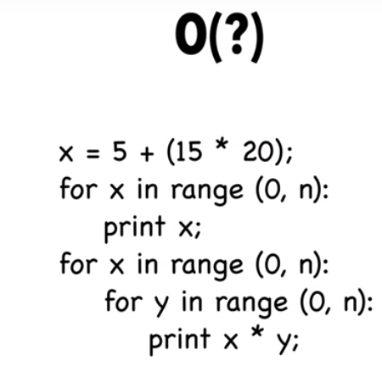
Solution:
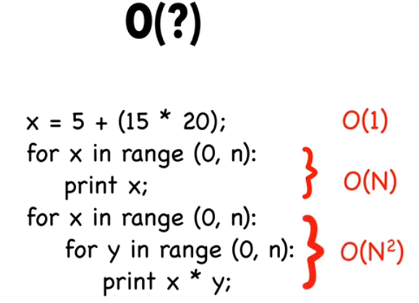

Here, the complexity is: O(n²)

Example:

Again reconsider A1 and A2 are two independent parts of an algorithm, with t1 and t2 as computation times respectively.
Now, whenever these two parts are in a decision structure, that means A1 is computed only when the given condition is true, otherwise, A2 is computed when the condition is false, denoted by A1 / A2, the total computation time is t1 / t2. According to maximum rule, the computation time denoted by max (t1, t2).

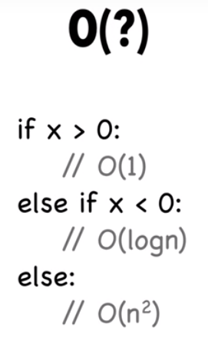

Since we choose worst case scenario, so we’ll choose O(n²)
Practice Problems:

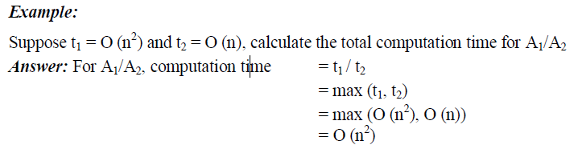

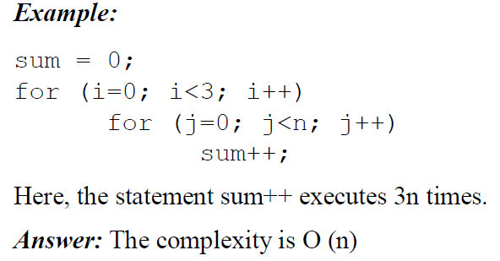

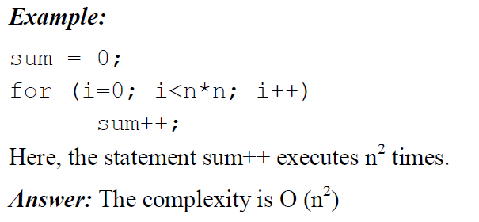
Let n=3. So the loop will run from 0 to 8 which is 9 iterations = 3²

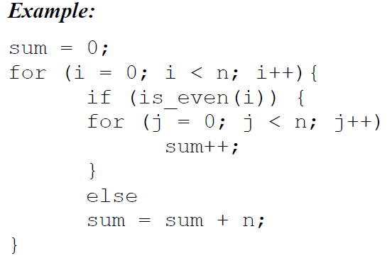
Here, inside the loop: if ―true clause executed for half the values of n, that is O(n) and if ―false
clause executed for the other half of n, O(1), so innermost loop is O(n). The outer loop is O (n).

Answer: The complexity is O (n²)

Summary:
Constant time algorithms [ O(1) ]:
This means that the algorithm requires the same fixed number of steps regardless of the size of the task.

Example: Array access, Push and pop operations for a stack, enqueue and dequeue operations
for a queue, other atomic operations.

2. Logarithmic time algorithms [ O (log n) ]:
Logarithm time algorithms mean that T(n) is upper bounded by logarithmic of the input size,
i.e. T(n) = log n.
Example: Binary search in a sorted list of n elements, Insert and Find operations for a binary search tree with n nodes, Insert and Remove operations for a heap with n nodes, etc.

3. Linear time algorithms [ O (n) ]:
Linear time algorithm means that for large enough input sizes the running time increases linearly with the size of the input.
Example: Array traversal

4. Linearithmic time algorithm [ O (nlogn ) ]:
An algorithm is said to run in linearithmic time when T(n) = O (nlogn ). Thus, a linearithmic term grows faster than a linear term, but slower than any polynomial in n with degree greater
than 1.
Example: Merge sort, Heap sort

5. Polynomial time algorithms [O (n^{k}), for k > 1 ]:
i) Quadratic time (O (n²)) algorithm: The number of operations is proportional to the size of the task squared.
Example: Slow sorting algorithms, for example, selection sort of n elements.
ii) Cubic time (O (n³)) algorithm: The number of operations is proportional to the size of the task cubed.
Example: Matrix multiplication

6. Exponential time algorithms [ O (k^{n}), for k>1 ]:
Exponential time algorithm means that T(n) is upper bounded by exponential expression of input size, i.e. T(n) = k^{n}
Example: Towers of Hanoi, implementation of recursive Fibonacci, generating all permutations of n symbols.

7. Factorial time algorithms [ O (n!) ]:
Factorial time algorithm means that T (n) is upper bounded by the factorial of the input size, i.e. T(n) = n!.
Example: Non-attacking n queen problem, traveling salesman problem by brute-force search.
The best time in the above list is obviously constant time, and the worst is exponential time, which, as we have seen, quickly overwhelms even the fastest computers even for relatively small n.

Polynomial growth (linear, quadratic, cubic, etc.) is considered manageable as compared to exponential growth.
Upper bound (Big O)
Time taken by a known algorithm to solve a problem with worse case input gives us the upper bound.
The growth of functions is often described using a special notation.
If f(n) and g(n) are functions defined for positive integers, then we write f(n) = O(g(n)) if there exist positive constants n_{o} and c such that
|f(n)| ≤ c|g(n)|, for all n ≥ n_{o}
In general, O (g (n)) = {f (n): there exist positive constants c and n₀ such that 0 ≤ f (n) ≤ cg (n) for all n, where n ≥ n₀}.
That is at the right of n₀, the value of f (n) always lies on or below cg (n). This notation gives an upper bound for a function to within a constant factor.

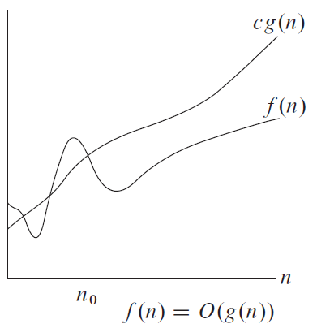

We write f(n) = O(g(n)) to indicate that a function f(n) is a member of the set O(g(n)).
We can also write f(n) ∈ O(g(n))
f (n) is O(g(n)) says that f (n) grows slower than some fixed multiple of g(n) as n grows without bound.

Example:
Show that f (n) = n ² + 2 n + 1 is O(n ²).
Solution.
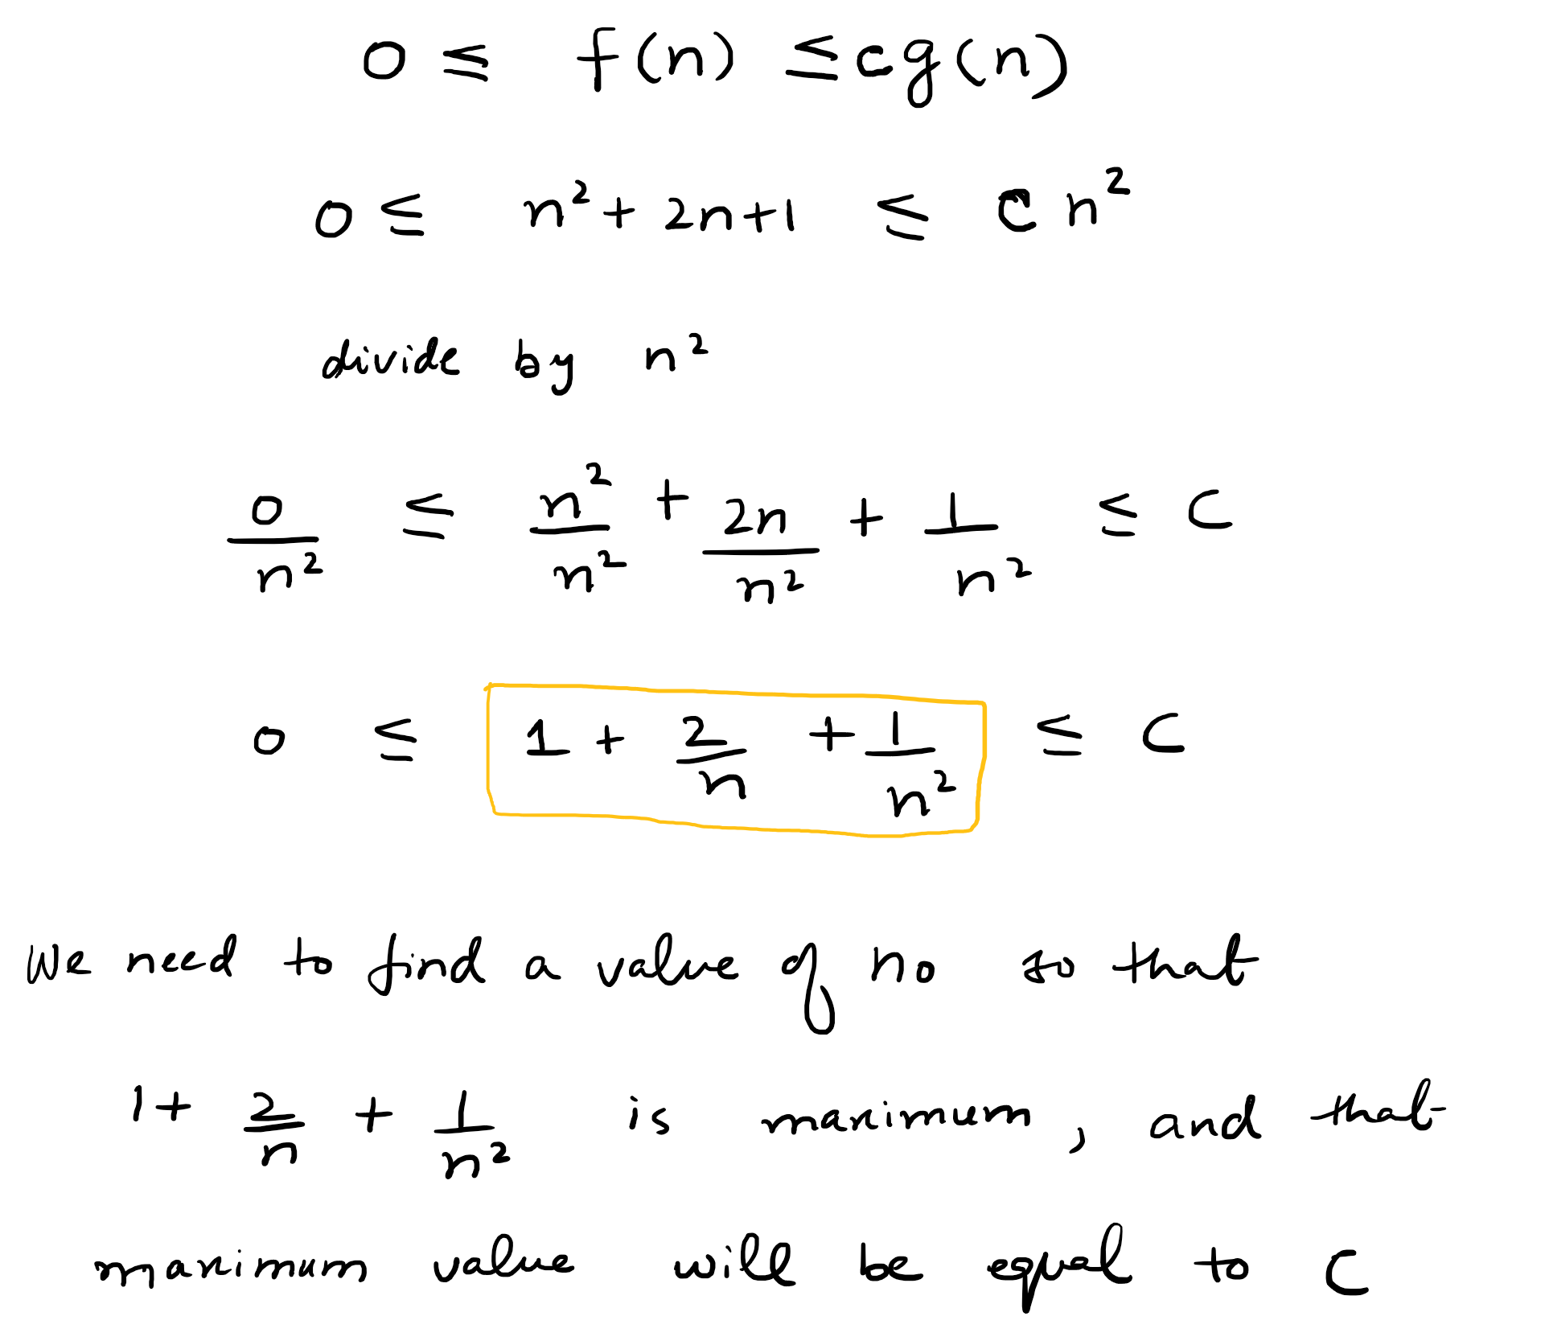
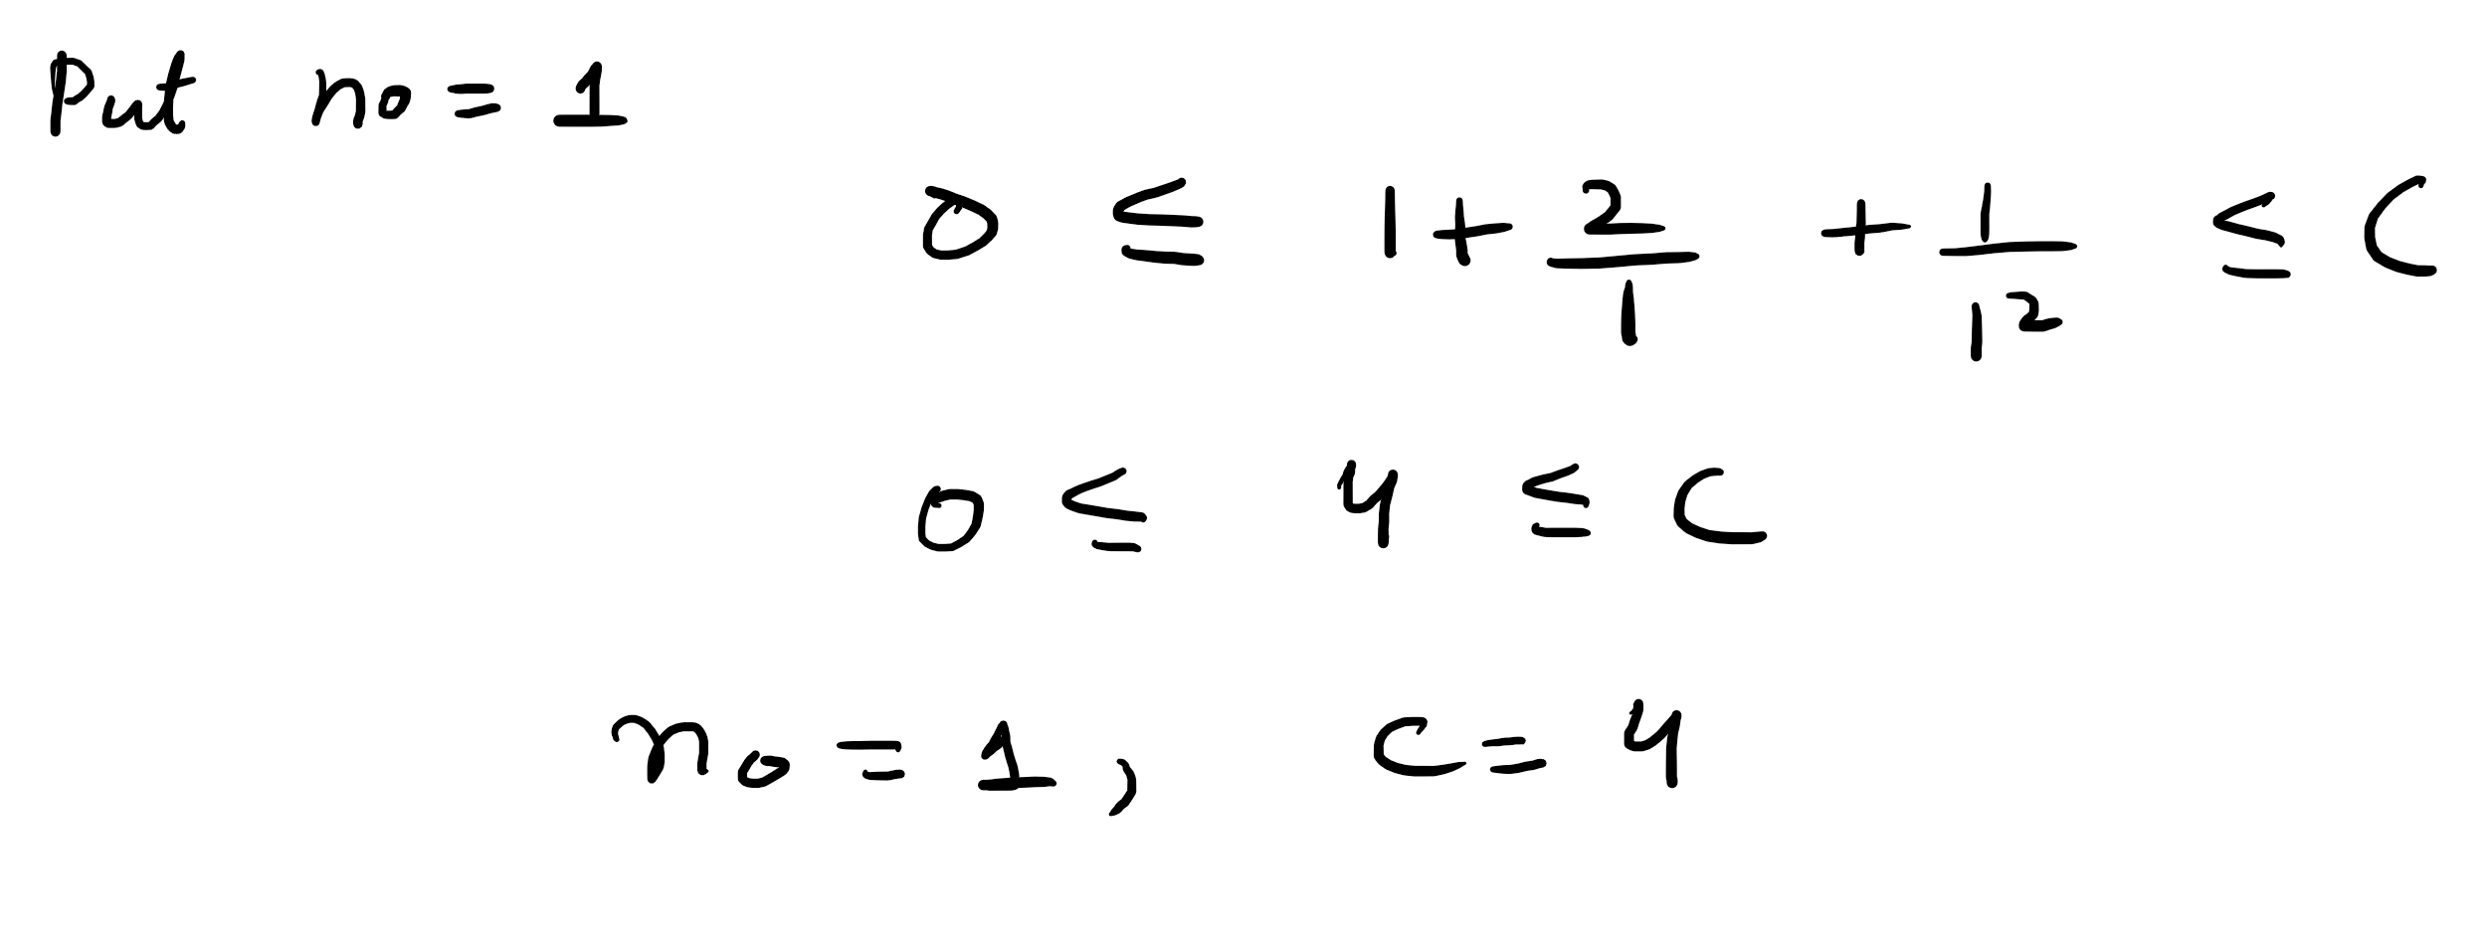

Example:
Show that 7n² is O(n³).
we can take C = 1 and k = 7 as witnesses

Example:
Suppose f (n) = 3n + 2
Now we can write f (n) = 3n + 2 ≤ 4n, for all n≥2, here g (n) = n, c = 4, n₀ = 2
Hence, we can write f (n) = O (g (n)) = O (n)

Example:
Suppose f (n) = 10n² + 4n + 2
Now we can write f (n) = 10n² + 4n + 2 ≤ 11n², for all n ≥ 5, here g (n) = n², c = 11, n₀ = 5
Hence, we can write f (n) = O (g (n)) = O (n²)
Example: Show that 4n² = O(n³)
Using formula
$$O≤f(n)≤cg(n)$$
Here f(n) = 4n² and g(n) = n³
Therefore $$O≤{4n}^{2}≤c.n^{3}$$
Divide by n³

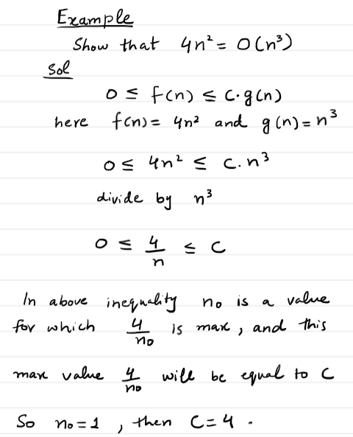

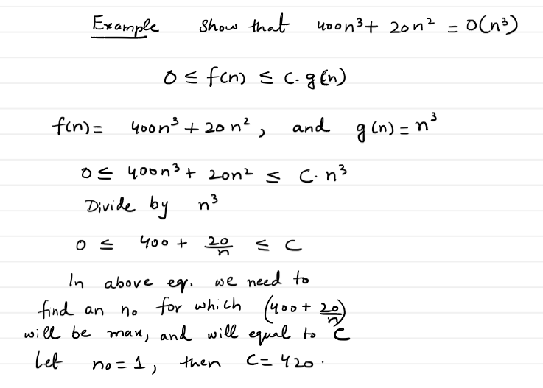

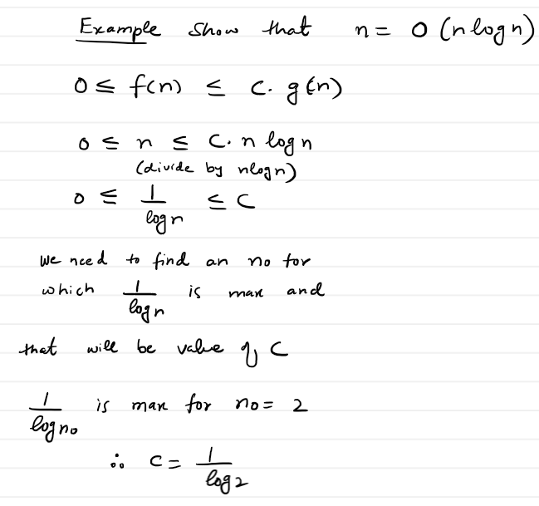

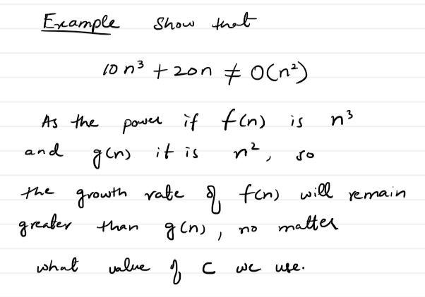
Limitations of Big O Notation
There are certain limitations with the Big O notation of expressing the complexity of algorithms.

These limitations are as follows:

- Many algorithms are simply too hard to analyse mathematically.
- There may not be sufficient information to calculate the behaviour of the algorithm in the average case.
- Big O analysis only tells us how the algorithm grows with the size of the problem, not how efficient it is, as it does not consider the programming effort.
- It ignores important constants. For example, if one algorithm takes O(n²) time to execute and the other takes O(100000n²) time to execute, then as per Big O, both algorithm have equal time complexity. In real-time systems, this may be a serious consideration.

Big-Ω (Omega) Notation (Lower Bound)
The Omega notation provides a tight lower bound for f(n). This means that the function can never do better than the specified value but it may do worse.
According to the lower bound theory, for a lower bound L(n) of an algorithm, it is not possible to have any other algorithm (for a common problem) whose time complexity is less than L(n) for random input. Also every algorithm must take at least L(n) time in worst case. Note that L(n) here is the minimum of all the possible algorithm, of maximum complexity.

It describes the best that can happen for a given data size.
If f (n) and g (n) are functions defined for positive integers, then we write
f (n) = Ω (g (n)) if there exist positive constants n₀ and c such that
| f (n) | ≥ c | g (n) |, for all n≥ n₀.

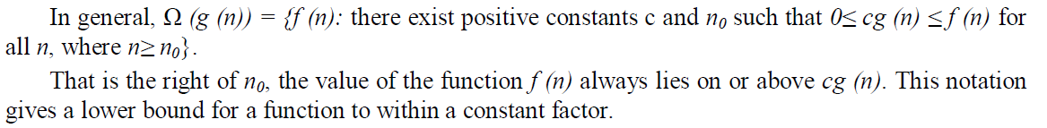

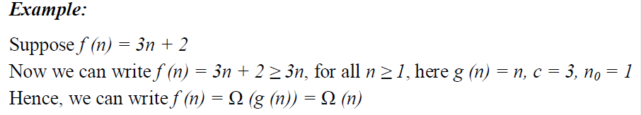

In below example, the no=1 (it is mistake)
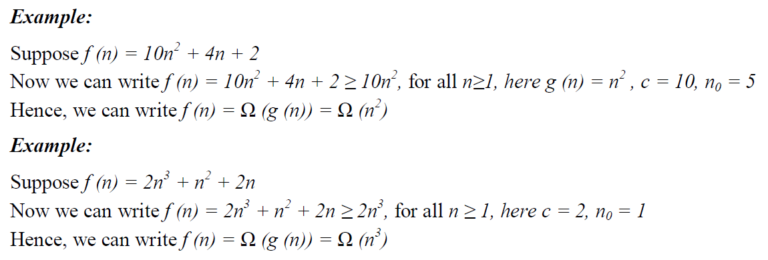

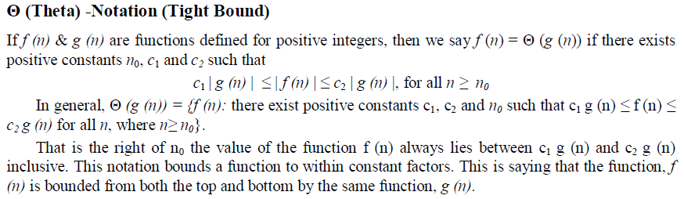

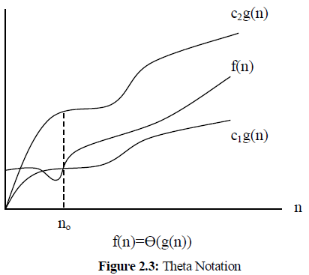

Recall:
if f(n) is O(g(n)) this means that f(n) grows asymptotically no faster than g(n)
if f(n) is Ω(g(n)) this means that f(n) grows asymptotically no slower than g(n)
if f(n) is Θ(g(n)) this means that f(n) grows asymptotically at the same rate as g(n)
As a result:
if f(n) is Θ(g(n)) it is growing asymptotically at the same rate as g(n). So we can say that f(n) is not growing asymptotically slower or faster than g(n). But from the above, we can see this means that f(n) is Ω(g(n)) and f(n) is O(g(n)).

Θ(f(n)) just denotes the upper AND lower bound. An algorithm is Θ(f(n) if and only if O(f(n)) AND Ω(f(n)).
What I mean is that if some function 𝑓(𝑛)=Θ(𝑛), then 𝑓(𝑛)=𝑂(𝑛), and also 𝑓(𝑛)=Ω(𝑛).

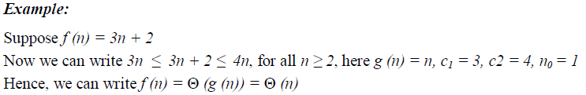

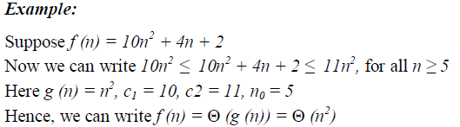

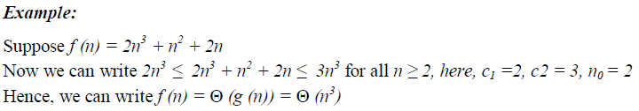

SUMMARY:
WHAT IS TIGHT BOUND?
Think of O as an upperbound, and Ω as a lower bound.
These bounds can be tight or loose, but we prefer to make them tight as possible.
If we have tight bounds where O and Ω have the same growth rate then we precisely know the growth rate.
If we can precisely give the growth rate then we know Θ.
An analogy is the height of a neighbour.
We can immediately say that the height of our neighbour is upper bounded by 1 million kilometers.
We can also say that the height of our neighbour is lower bounded by 1 nanometer.
These statements aren't very useful, because these bounds are so loose.
However if we gave a lower bound for the height of our neighbour at 5' 5", and an upper bound of 5' 10" we would have a much better idea of how tall our neighbour was.
If we had a lower bound of 5' 8" and an upper bound of 5' 8" we could then say that our neighbour is 5' 8".

Difference between Loose bound, tight bound, lower bound, upper bound
If I have 10 million dollars in my bank account, but I tell people I have at least 10 dollars, I am 100% correct about my claim. However, I am not being precise since I left a lot of "headroom". The headroom is 10 million minus 10 dollars, where 10 dollars is the "Big-Omega", and the "Big-O" is 10 million, and the "Big-Theta" is the headroom of between 10 dollars and 10 million dollars. Best I can express in simple high level human language, in terms of precision: In my bank account is an amount of money between "Big-Omega"($10.00) and "Big-O"($10,000,000). Meaning, conversationally, I just told someone that the range of money that I can spend at will is "Big-Theta"(from $10.00 to $10,000,000).

Can we always find tighter bound?

Typically, if we design an algorithm and perform some quick analysis on it we find a reasonable O value (it doesn't have to be tight, but it shouldn't be too loose).
Often, that's all we care about.
Sometimes, we then find a reasonable Ω value (again it doesn't have to be tight, but it shouldn't be too loose).
Then, if it is critical to have tight bounds, or if the algorithm is easy to analyze we tighten up the bounds on O and Ω until they are the same and then we have Θ.
A typical scenario is: we have some task that our program needs to perform.
Often, we don't care about which algorithm we use as long as the asymptotic complexity of the algorithm is under some limit i.e. the algorithm is fast enough for our needs.
If we write an algorithm that gets the job done, but it is hard to analyze, we can often make simplifying assumptions that make the analysis easier but the bounds looser.
e.g.
Suppose I had some code that looked like this:
for(var j=1; j<=n;j++){
var number= some_hard_to_analyze_calculation(j);
if (number <1){ number=1;}
if( number >n){ number=n;}
for(var k=1; k <=number;k++){
do_some_simple_stuff();
}
}
I could quickly see that the outer for loop loops n times.
I can see that, just before the inner for loop, number is some value between 1 and n.
So the inner for loop, loops at most n times.
Since outer_loops * inner_loops = n * n=n^2, I could say that the running time is O(n^2)
If I only cared that the algorithm runs no slower than O(n^2) I could stop analyzing.
Suppose I was also concerned about the lower bound (we often don't care about the lower bound as much),
I can see that the inner for loop loops at least 1 time.
Since outer_loops * inner_loops =n * 1=n, I could say that the running time is Ω(n)
So now I would know that this algorithm has a running time that is Ω(n) and O(n^2)
Since the calculation is hard to analyze I might not be able to tighten up Ω or O.
If I can't tighten up the bounds on Ω or O, I can't figure out Θ.

Binary search:

The worst-case running time for binary search is log(n).
So for log(n) we could say:
log(n) is O(n^n) since log(n) grows asymptotically no faster than n^n
log(n) is O(n) since log(n) grows asymptotically no faster than n
log(n) is O(log(n)) since log(n) grows asymptotically no faster than log(n)
We went from loose upper bounds to a tight upper bound
log(n) is Ω(1) since log(n) grows asymptotically no slower than 1
log(n) is Ω(log(log(n))) since log(n) grows asymptotically no slower than log(log(n))
log(n) is Ω(log(n)) since log(n) grows asymptotically no slower than log(n)
We went from loose lower bounds to a tight lower bound
Since we have log(n) is O(log(n)) and Ω(log(n)) we can say that log(n) is Θ(log(n)).

Question for anyone. Why did Cameron use "Ω(log(log(n)))" when going from loose bounds to tight bounds?

As Cameron notes, we use omega to signify a lower bound. If something equals Ω(log(log(n))), it means only that that something will never be lower than log(log(n)). Because log(n) would always be a higher number, it would "tighten" up the lower boundary. For example, if n equals 100, saying "n is no lower than 50" wouldn't be as tight a bound as saying "n is no lower than 90." The tightest bound would be "no lower than 100." In the same way, Cameron's tightening his lower bound from log(log(n)) log(n).
You might wonder why his loosest lower bound is 1 -- can't log(n) be even lower than 1? Well, it can purely mathematically, but when using this in terms of number of code operations, the code will have to execute at least one time, making it an appropriate lowest bound to use.

